Group: Amy Reynolds, Oleg Mironov, Kundyz Smith

Where is the best place to live in Texas with good schools, available jobs and good air quality?

There are many different websites that examine these indicators separately and a few that examine two or more for specific areas of Texas but not one that looks at all three for the entire state. We will have a base layer of the map of Texas with county lines. The top layer will be Demographics, another layer will be Education and another layer for Health. Demographics will review income per capita, unemployment. Schools will review age ranges and school ratings. Health will review air pollution and allergens on a real time basis. These will all be loaded in SQLite

Oleg:

Data Source: <https://geofred.stlouisfed.org/>

Median Household Income Data:

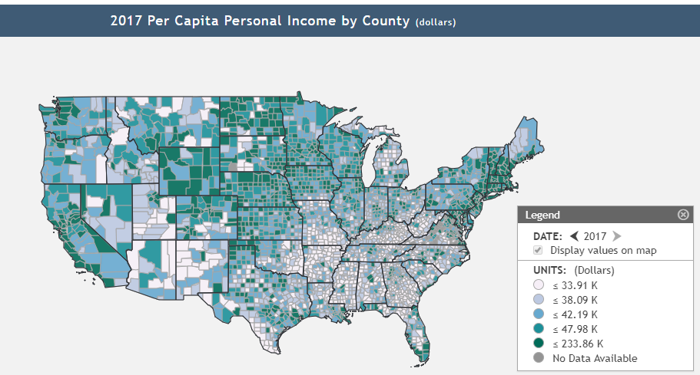

Unemployment Rate by County:

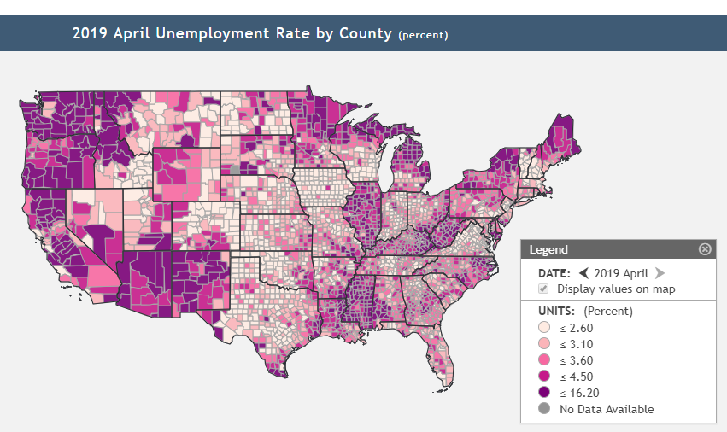

Air quality / allergens

Amy

Data source real time data: <https://docs.airnowapi.org/aq101>

Verified historical data: <https://aqs.epa.gov/aqsweb/documents/data_api.html>

Documentation: <https://aqs.epa.gov/aqsweb/documents/data_api.html#signup>

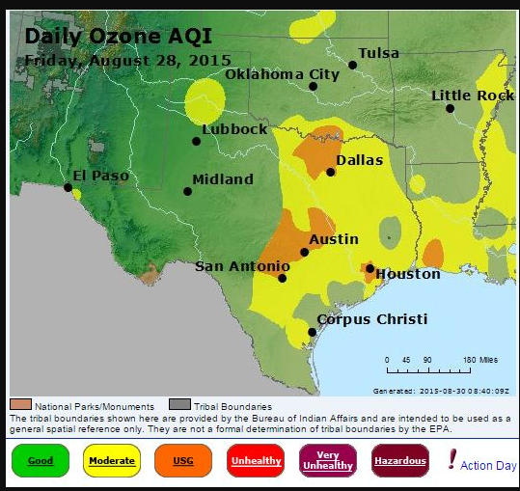

Kundyz

Education:

<https://developer.schooldigger.com/>

backup option: <https://www.greatschools.org>

